30 days of akuru 2019

Month: june 2019
Theme colour: orange

Guidelines and description

What is #30daysofakuru
#30daysofAkuru first edition, is an open call to visual designers,
illustrators, type designers, typographers and anyone who’s interested
in explore the endless possibilities and new dimensions of Sinhala letterforms, sinhala script. We challenge you to create your own new and exciting interpretation of a selected Sinhala letter, one letter per day for the Month
of June. The project aim is to create an awareness and importance of sinhala typography and it’s endless typography and graphic possibilities.
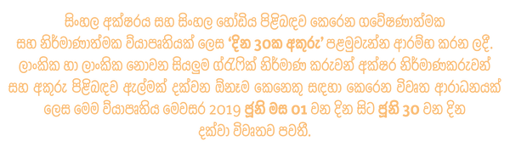

how to participate
#30daysofAkuru first edition takes place from
1st of JUNE to 30th of JUNE 2019.

Each participant is invited to share their works via Instagram.
In order to take part the participants need to check the selected Sinhala letters given for each day in our #30daysofAkuru calendar.

We ask you to upload your artwork to your Instagram profile making sure it’s uploaded on it’s corresponding day. Also make sure to tag us @30daysakuru on your art work directly and always add the project hashtags #30daysofAkuru #30daysofAkuru_day1 etc, in your post caption; as the only way for us to identify your artwork and allow others to see it.

Don't have an Instagram?
No worries you can still participate. All you have to do is send us your submissions through our facebook.com/akuruCollective page, along with
your name and the art work description.

We strongly encourage you to participate by designing all 30 Sinhala letter characters, but you can also participate for few days by designing selected letter characters or a single letter character. It’s all up to you to decide which to do but make sure to check the #30daysofAkuru calendar.
​
Image format is jpg/png square format 1080px X 1080px.
Video or motion design entries in all formats are welcome.
​
To submit your work use @30daysakuru direct image tagging system
and hashtags such as #30daysofAkuru #30daysofAkuru_day1 etc.

From all the daily entries, we will curate a selected artworks by our team
and will be publish on @30daysakuru Instagram page and other social media network related to the project. In addition to our daily curated selection from
all the submissions, at the end of this edition on 30th JUNE. A panel of Type
and Graphic designers will pick winners from those who have participated submitting the most unique, creative or innovative set of more than
20 sinhala letterforms.
The Selected letters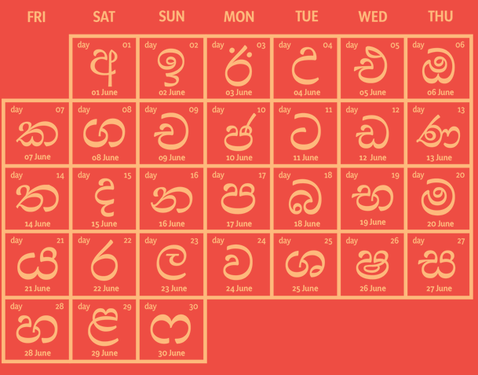

About us
#30daysofAkuru is a project hosted by Akuru Collective and organised by the
Letters.Lanka team. our aims are to inspire interests in letterforms and highlight regional graphic designers, graphic and visual design artists and illustrators to create talent in varieties of sinhala font design and bring awareness about the importance of expanding typography.

Post captions

Coming soon

GOOD NEWS!
Our brand new project #30daysofAkuru - First Edition, is an open call to Visual designers, Illustrators, Type designers, Typographers and anyone who’s interested in exploring the endless possibilities and new dimensions of Sinhala letter-forms and Sinhala script.
We challenge you to create your own new and exciting interpretation of a selected Sinhala letter, one letter per day, for the month of May.The aim of this project is to create awareness and importance for Sinhala typography and its endless typographic and graphical possibilities.

Stay tuned for more details!

#typography #sinhalaletteting#sinhala #sinhalaalphabet#sinhalatypography #30daysofakuru#graphicdesigner #srilankandesigner#lettering #sinhalacalligraphy#letterslanka

Caldender
#30daysofAkurucalendar
Be on track with the official calendar for the 1st edition of #30daysofAkuru. Make sure to check the selected Sinhala letters given for each day.

Save the dates!

About event

If you still don’t know what goes on at #30daysofAkuru, here’s a little intro to our project. Also check our official project website for more info! www.letterslanka.wixsite.com/30daysakuru for more information.

We start tonight
We are starting our #30daysofakuru submissions tonight 12 midnight onwards.✍️If you still don’t know what goes on at #30daysofAkuru, check our website link in the bio✍️
Submissions will begin by tonight midnight onwards(june 1st) ✍️upload your artwork to your Instagram making sure it’s uploaded on it’s corresponding day. ✍️Also make sure to TAG US @30daysakuru. ON your art work directly and always add the project hashtags #30daysofAkuru#30daysofAkuru_day1 etc, in your post caption; as the only way for us to identify your artwork and allow others to see it.✍️We strongly encourage you to participate by designing all 30 Sinhala letter characters, but you can also participate for few days by designing selected letter characters or a single letter character. ✍️It’s all up to you to decide which to do but make sure to check the #30daysofAkurucalendar.
​
Image format is jpg/png square format 1080px X 1080px
Video or motion design entries in all formats are welcome.
​
To submit your work use @30daysakuru direct image tagging system and hashtags such as #30daysofAkuru#30daysofAkuru_day1 etc.

First day
It’s June 1st! Day 1
lets get drawing! #30daysofAkuru.

Always make sure you tag us @30daysakuru on your art work directly and add the hashtags #30daysofAkuru#30daysofAkuru_day1 etc, in your post caption; This way, we can keep track of your artwork and feature them for everyone to see!

Enjoy! #30daysakuru

Last day
Day 30 LAST DAY!!!
lets get drawing! #30daysofAkuru.

Always make sure you tag us @30daysakuru on your art work directly and add the hashtags #30daysofAkuru#30daysofAkuru_day1 etc, in your post caption; This way, we can keep track of your artwork and feature them for everyone to see!

Enjoy! #june 30

Task
Selected 30 sinhala letter characters along with two special characters that includes on tamil character, we have completed the 30 days of akuru phase one in the month of june 2019. All the details regarding the letter characters and how many submissions happened on each letter along with the person who has submitted, can check through This link.

Number of Characters: 32 (30+2special)
Number of participants: 148
Number of submissions: 1083
Number of participants who submit more than 20 letters: 18
The most popular character : ක (58 submissions)

Mentions in media: daily ARTRA, Sunday observer, dinamina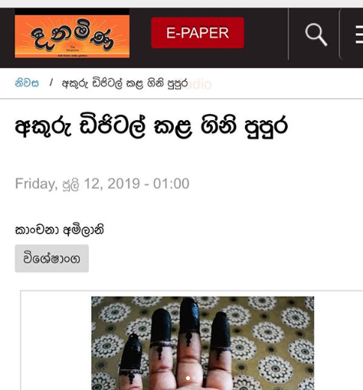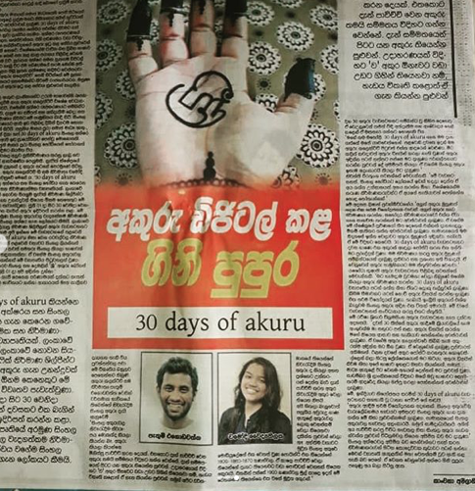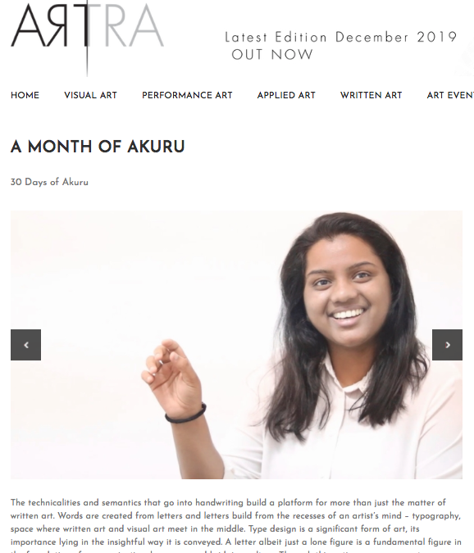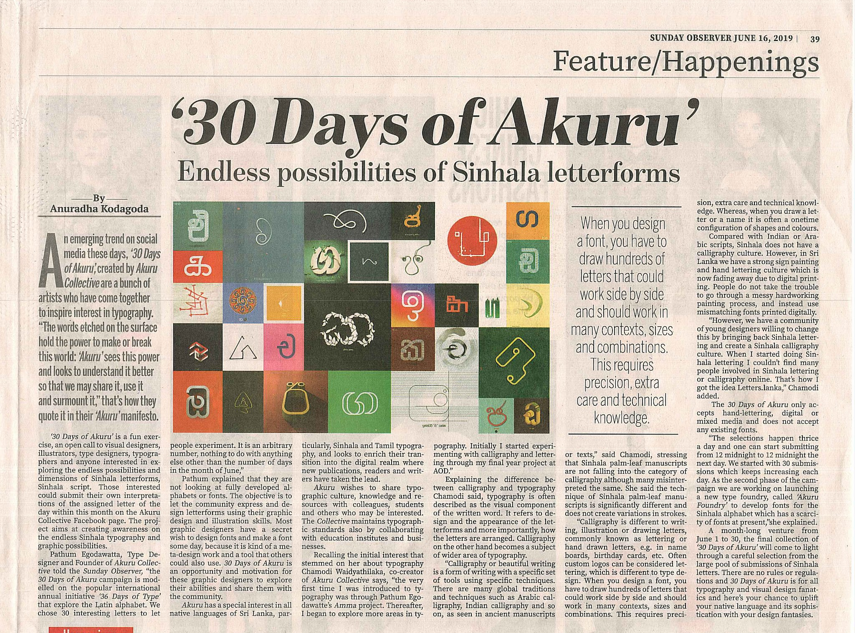

Akuru fan comments

Organizing an event to encourage letter making lovers and designer, is great help to their upbringing and gaining creativity. #30daysakuru gives me great joy since it was started. And it changed my way of thinking about how sinhala type faces should be.--Lishan Puwakovita

A really great idea, I have wanted to do Sinhala lettering but never had a solid reason to start doing it. In the end it was really fun--Pasindu Attale

I have learn that some sinhala letters has more than one expression. Those curves can do magical things. ---Kanchana Amilani

I learned how beautiful both Sinhala and Tamil letters are... As I had to combine Sri letter in both languages. Never paid this much attention to details before.. loved it.-Thilini

A magazine or a compendium made after the akuru challenge with all or selected submissions --Pasindu Attale

Summary Video lineup

30days logo
Year ‘2019’
30 letters + 2 =32
Number of participants: 148
Number of submissions: 1083
Mentions in media: daily ARTRA, Sunday observer, dinamina
Fan comments-

Organizing an event to encourage letter making lovers and designer, is great help to their upbringing and gaining creativity. #30daysakuru gives me great joy since it was started. And it changed my way of thinking about how sinhala type faces should be.--Lishan Puwakovita

A really great idea, I have wanted to do Sinhala lettering but never had a solid reason to start doing it. In the end it was really fun--Pasindu Attale

